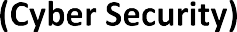

10
11
12
13
14
15
16
17
18
19
20
21
22
23
24
25
26
27
28
29
30
31
32
33
34
35 | 25270718 | Salman Nissar
36 | 25194365 | Imaan Sidiqui
37 | 25270420 | Hames Omar Wani
38 | 25270287 | Adnan Mujtaba Dar

